**Practical No. 5**

**Aim: Study and implementation of identity management**

**Step1: Click on link below.** [**https://aws.amazon.com/console/**](https://aws.amazon.com/console/)

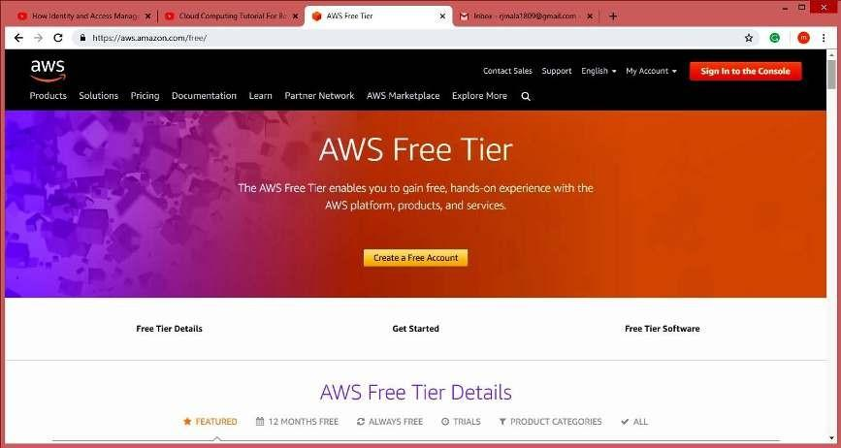

**Step2: Go to “My Account” > “AWS Management Console”**

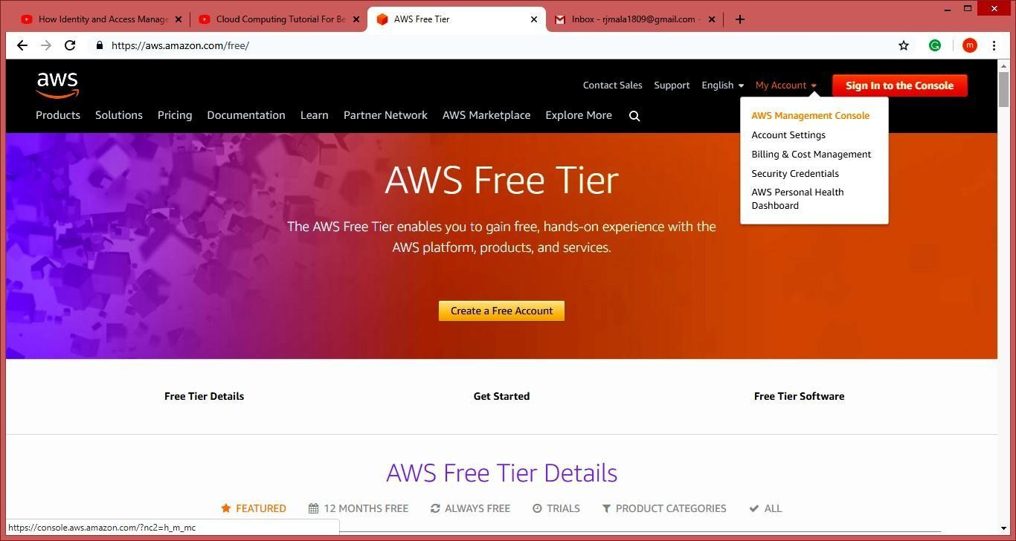

**Step3: Create** **AWS** **account (fill** **the** **required** **details)**

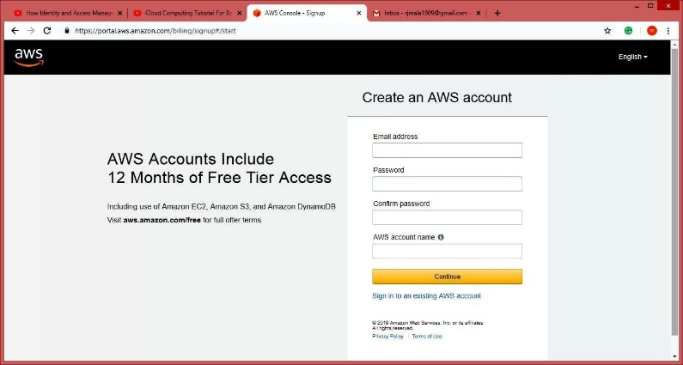

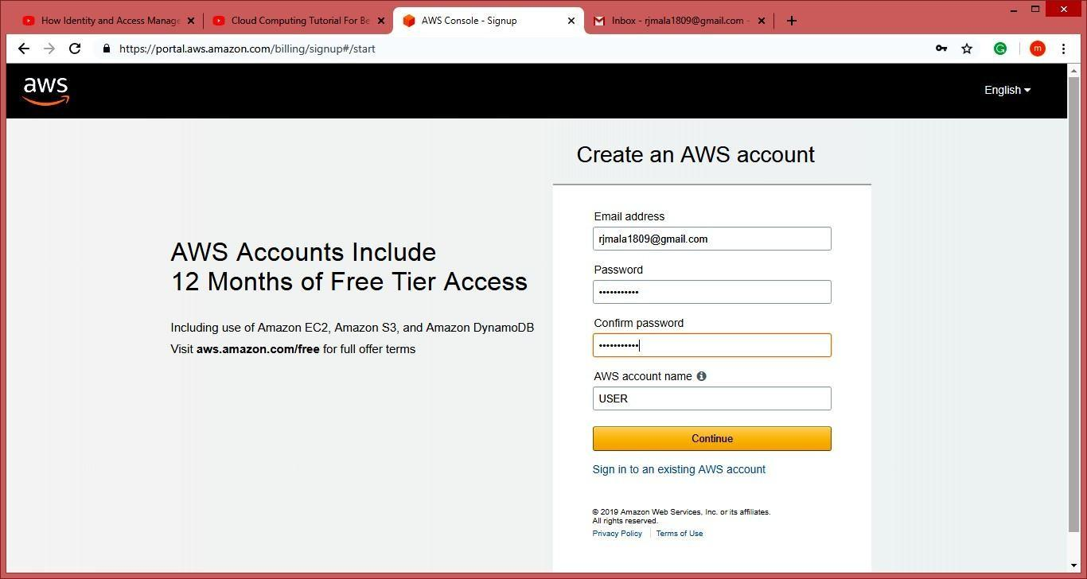

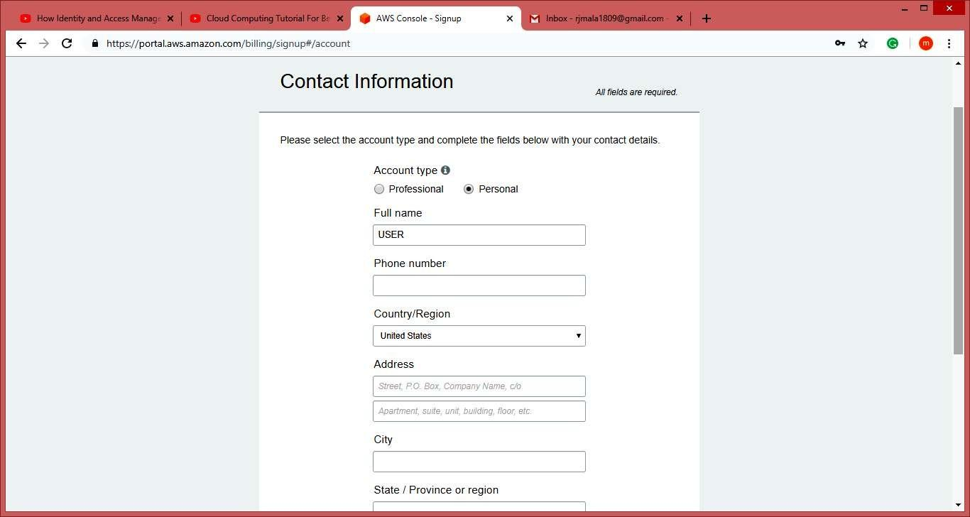

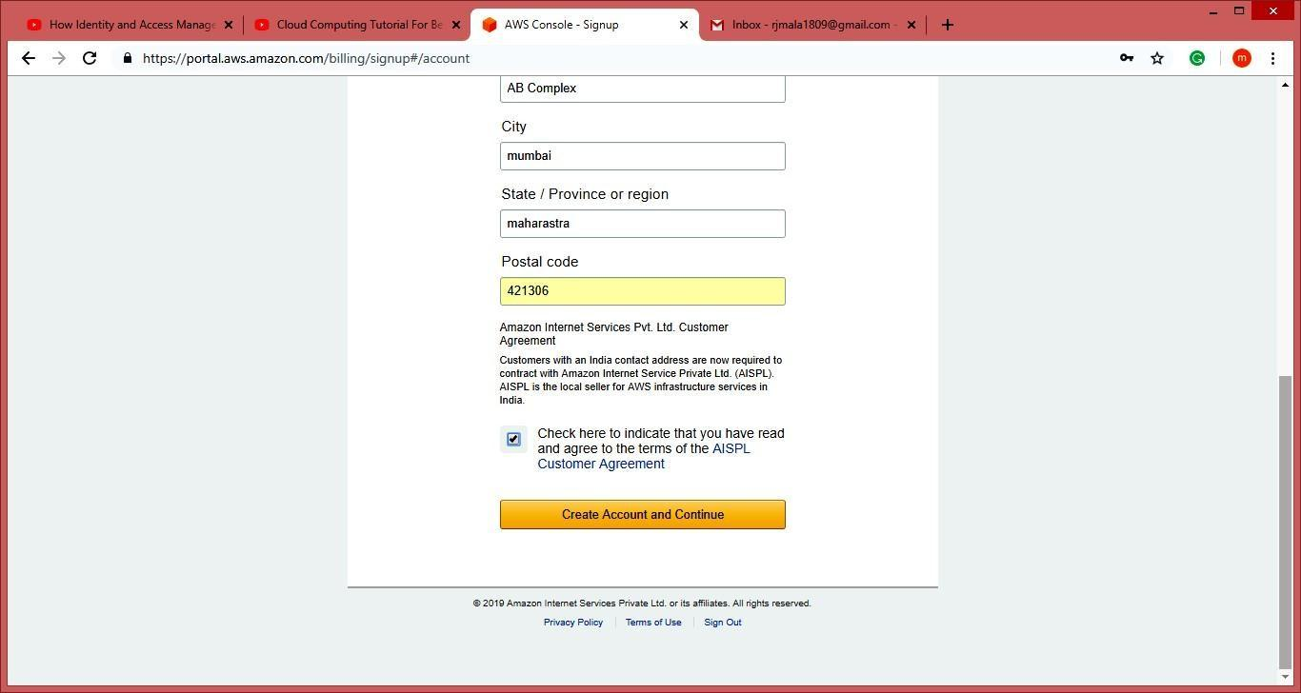

**NOTE: Do** **not** **provide** **any** **kind** **of** **credit/debit** **card** **details** **or** **bank** **details.)** **Click** **on** **next**

**Step 4: Click** **on** **My** **Account,** **Select** **AWS** **Management** **Console.**

**Enter** **your** **aws** **account** **userid** **and** **password** **click** **on** **sign** **in** **button**

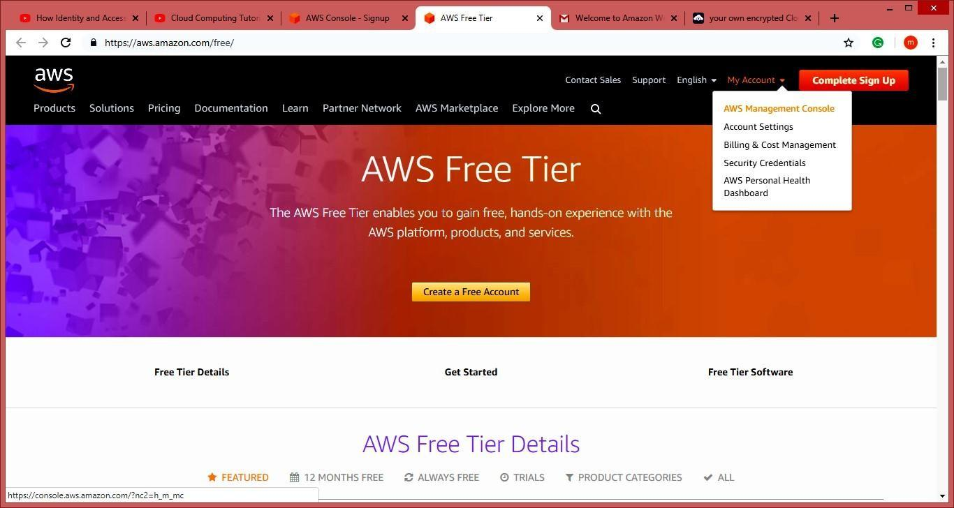

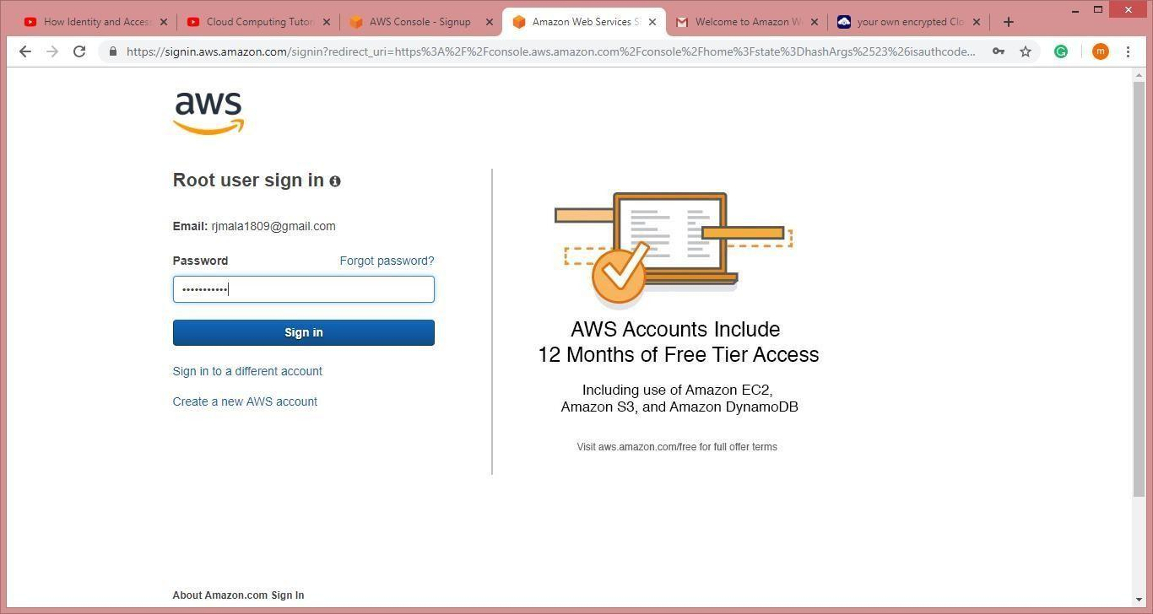

**Now** **it** **will** **redirect** **you** **to** **home** **page** **without** **asking** **any** **other** **details.** **Now** **to** **we** **have** **to** **add** **user** **and** **group** **and** **assign** **them** **privileges.**

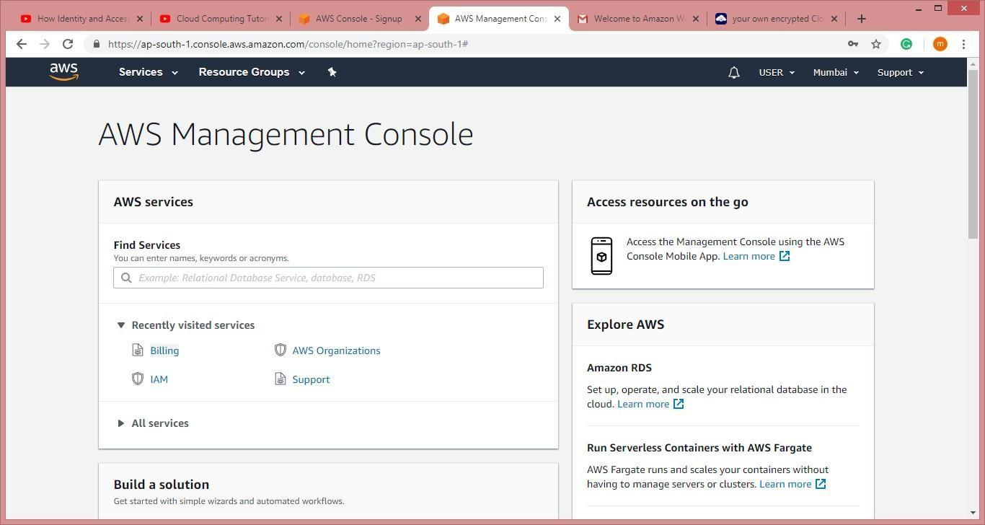

**Step 5: Go to “My Security Credentials”. Click on “Users”.**

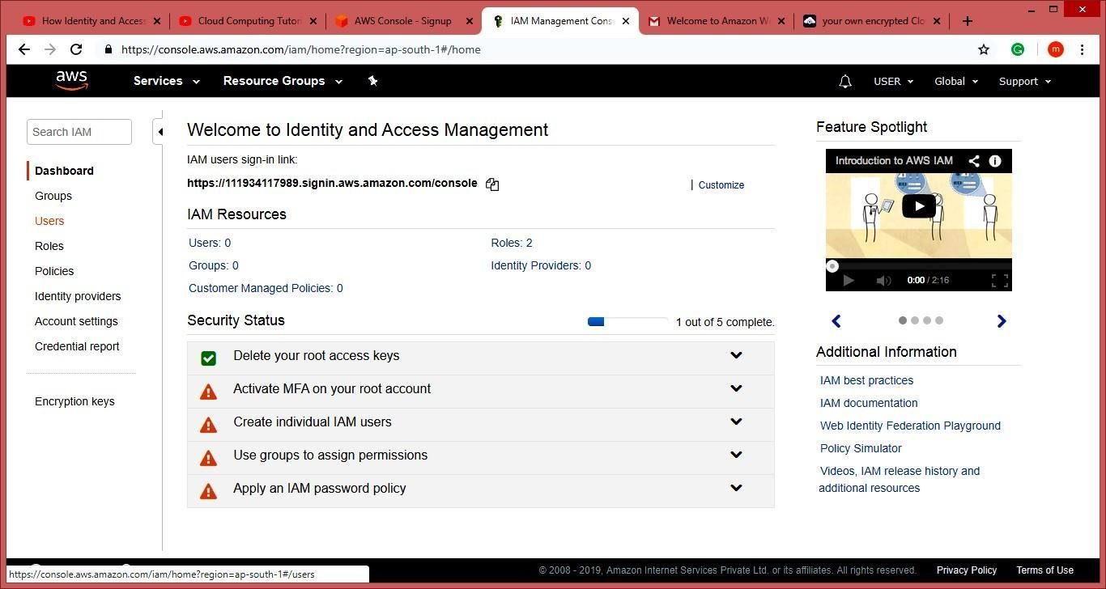

**Step6: Click on “Add user”.**

**Enter the name for the user. Check the check box in front of “Programmatic access” and “AWS Management Console access”.**

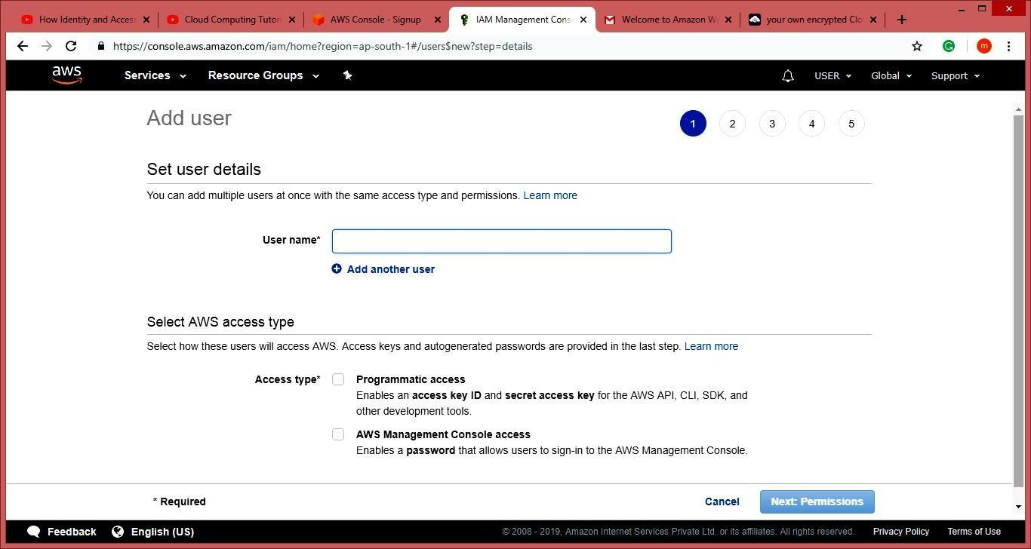

**Step7: Scroll down and select “Custom password” and enter the password for the new user and**

**Click on “Next: Permissions”.**

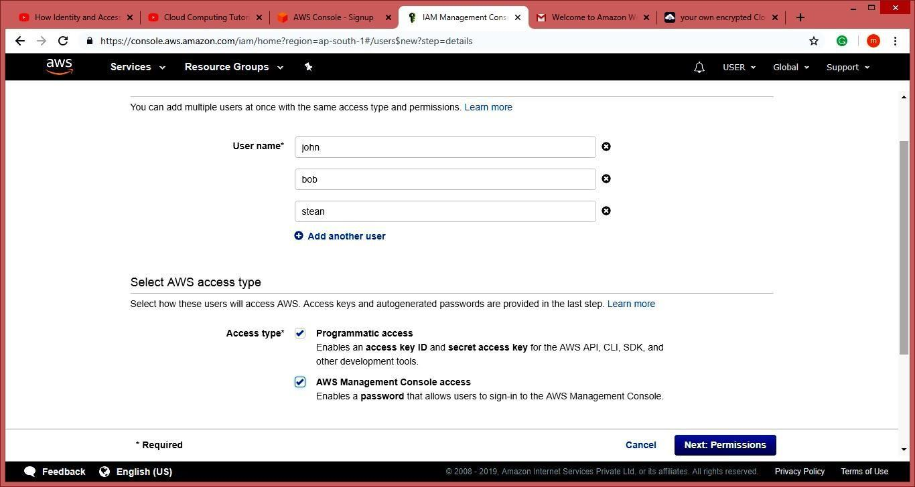

**Step8: Next** **it** **allow** **you** **to** **create** **group** **or** **you** **can** **just** **pass** **it.** **We** **are** **going** **to** **create** **group** **click** **on**

**“Create group”.**

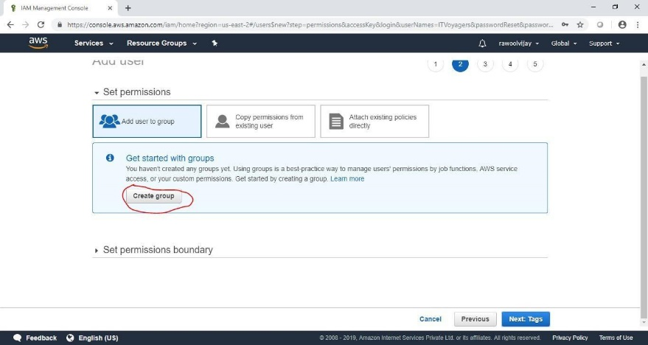

**Following window will appear.**

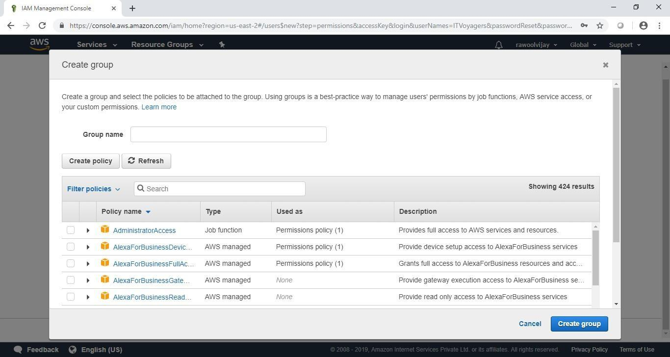

**Step9: Give** **name** **to group, assign the their permissions and click on “Create group”.**

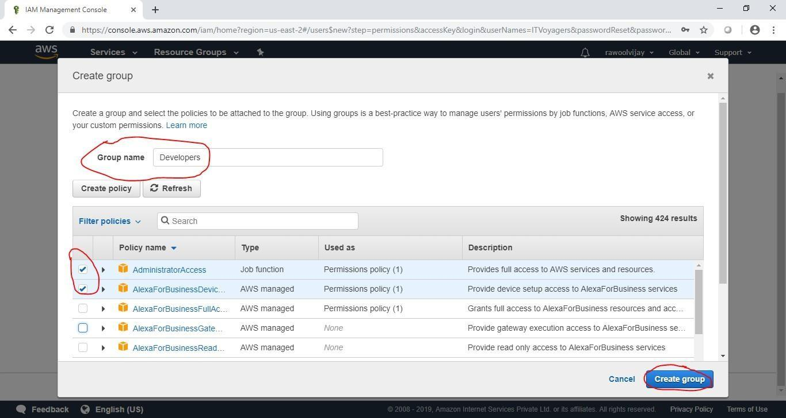

**Step10: Your group is created now click on “Next: Tags”.**

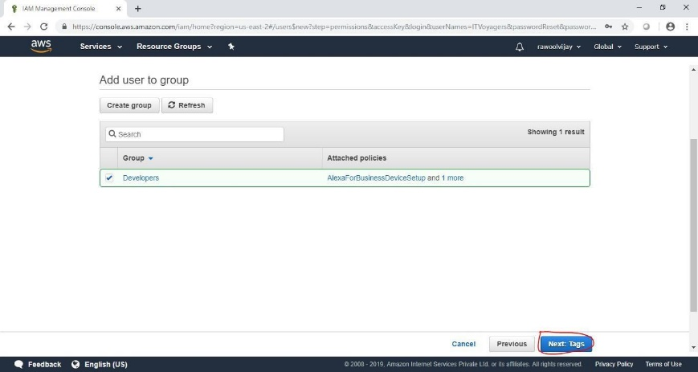

**Step11: Click on “Next: Review”.**

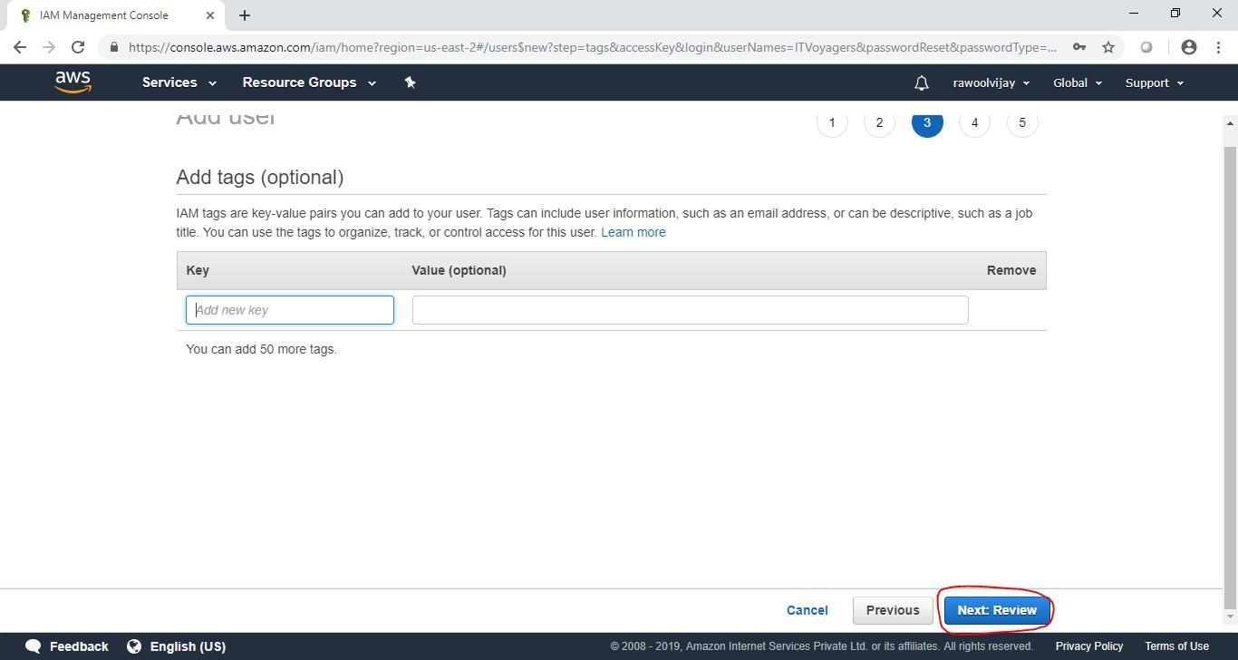

**Step12: Check the Review for the user and click on “Create user”.**

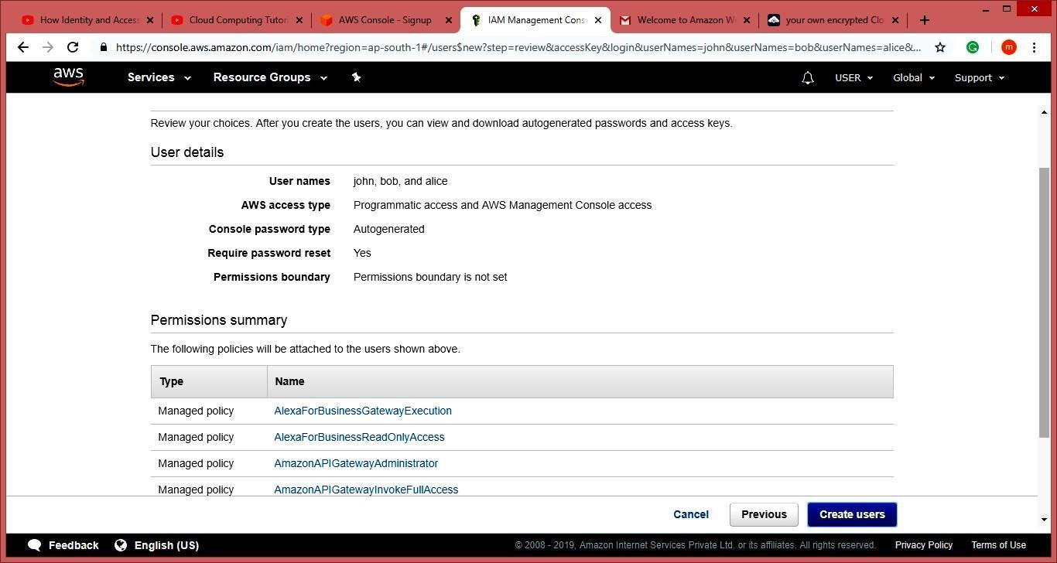

**Step13: Click on “Close”.**

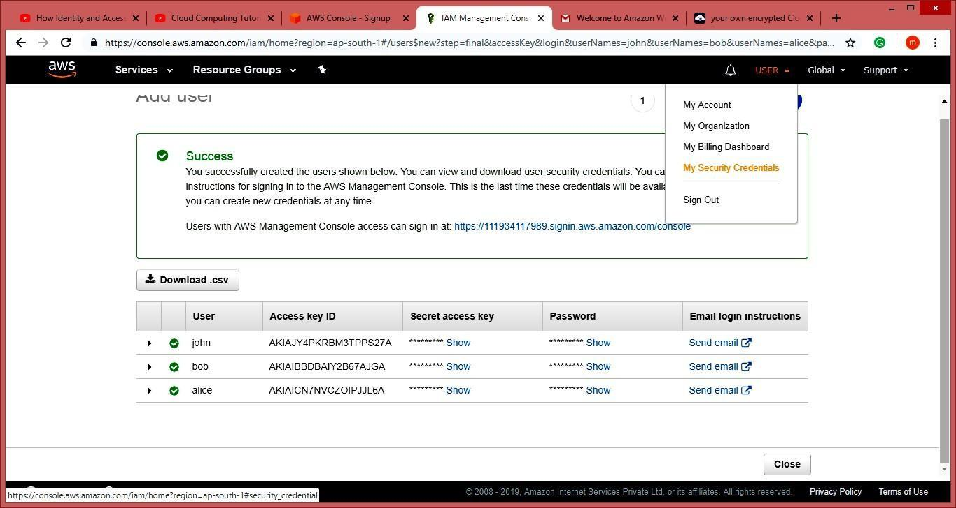

**Step14: Click on “Group”. You will see the group you just created.**



**Step15: Now** **log** **out** **of** **admin** **account** **and** **try** **to** **login** **as** **user** **(newly** **created).**

**Navigate to link below.** [**https://aws.amazon.com/console/**](https://aws.amazon.com/console/)

**Go to “My Account” > “AWS Management Console”.**



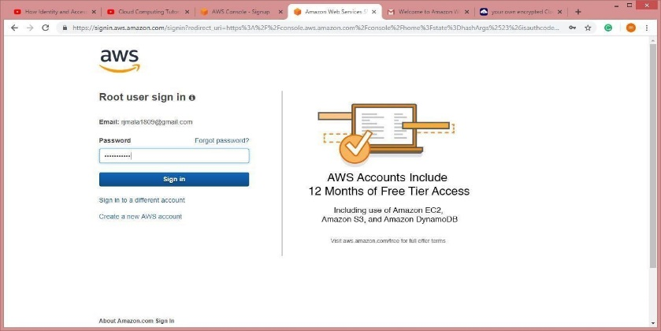

**It** **will** **ask** **you** **to** **change** **the** **password** **which** **is** **been** **set** **by** **administrator.** **You** **will** **be** **redirected** **to** **home** **screen.**



**Practical No. 6**

**Aim: Study Cloud Security Management**

**Step1:** Go to aws.amazon.com

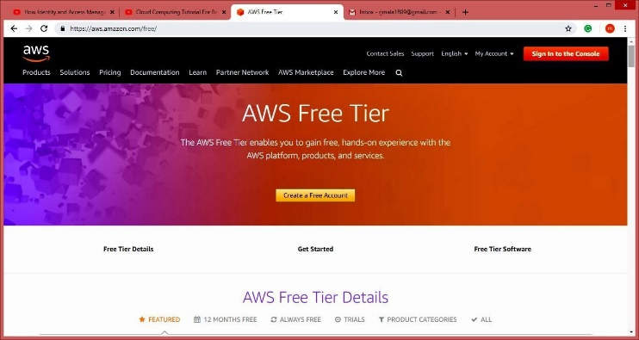

**Step2:** Click On My Account.

**Step3:** Select aws management console and click on it.

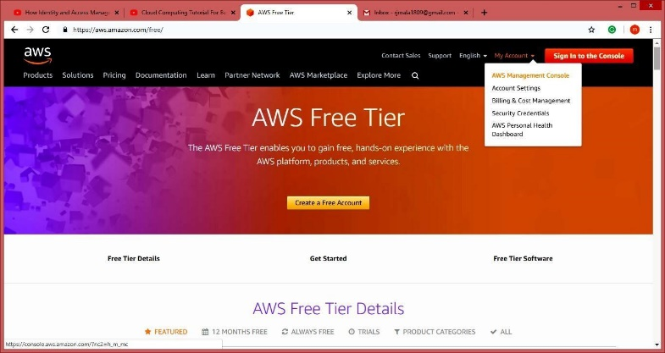

**Step4:** Create AWS account(fill the required details)

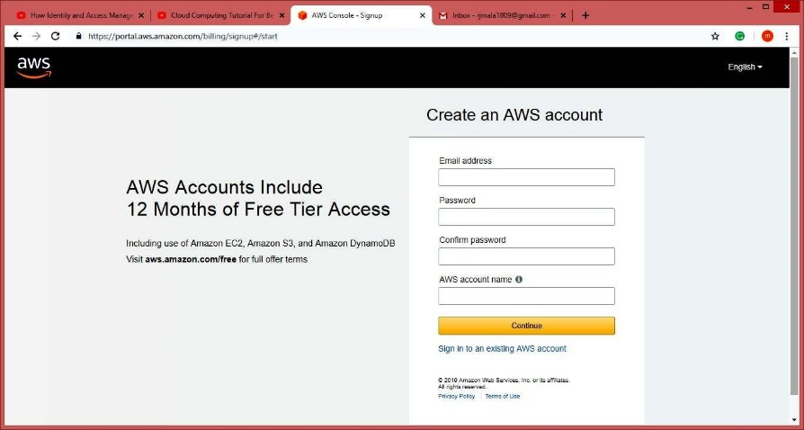







**NOTE :-** **Do** **not** **provide** **any** **kind** **of** **credit/debit** **card** **details** **or** **bank** **details.)**

**Step5:** Click on next (open your gmail check you will get message from amazon).

**Step6:** Click on My Account, Select AWS Management Console.

**Step7:** Enter your aws account userid and password click on sign in button





**Step8:** Click on Services tab



**Step9:** Click on Security, identity & Compliances > Select IAM

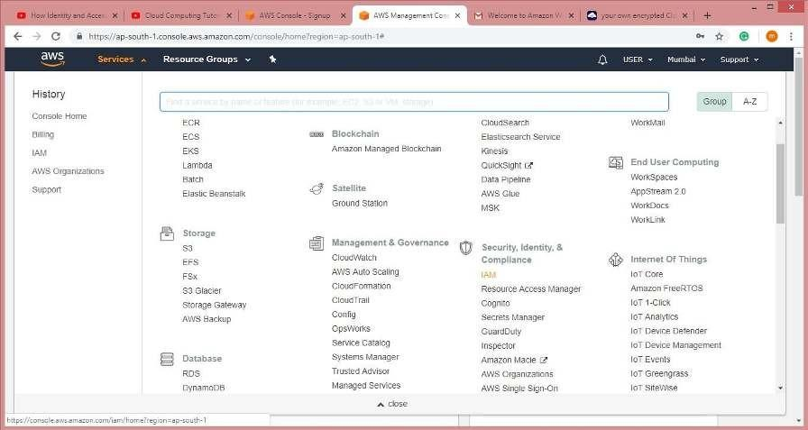

**10:** Click on Users from Dashboard



**Step11:** Click on Add User and Add the users.



**Step12:** Goto Select AWS access type check both the rediobutton. And click on next permission



**Step13:** Click on Attach Existing Policy Directly. Attach Policy to the users. And press Next Tab.

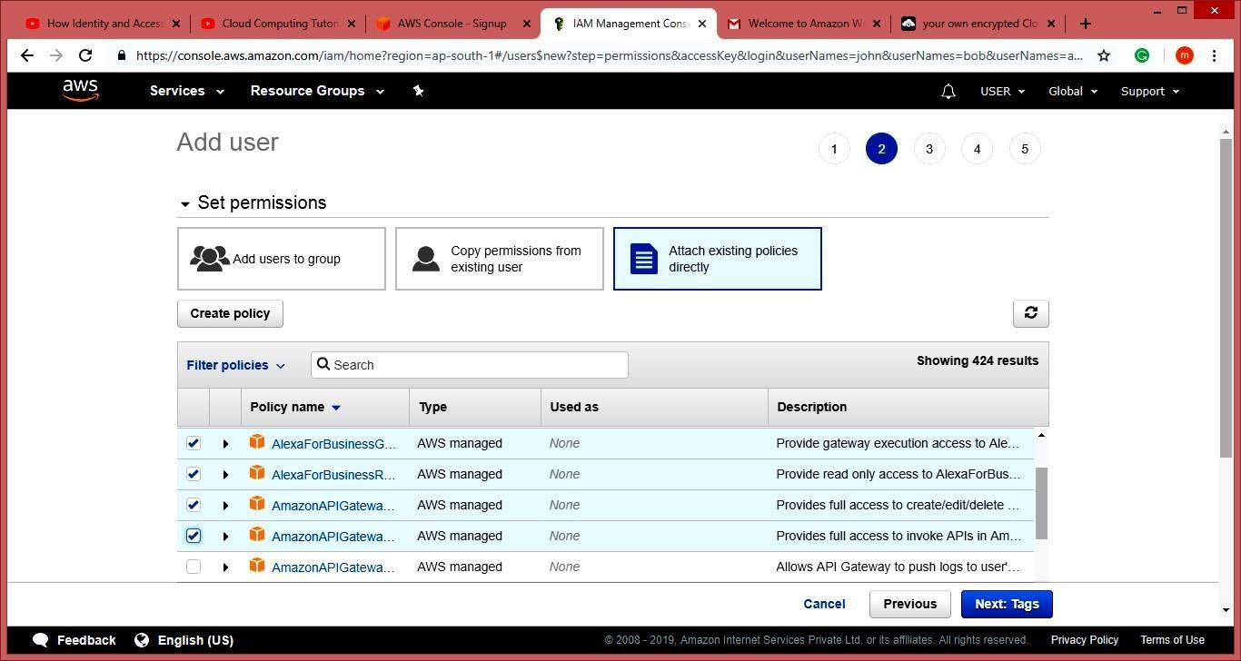

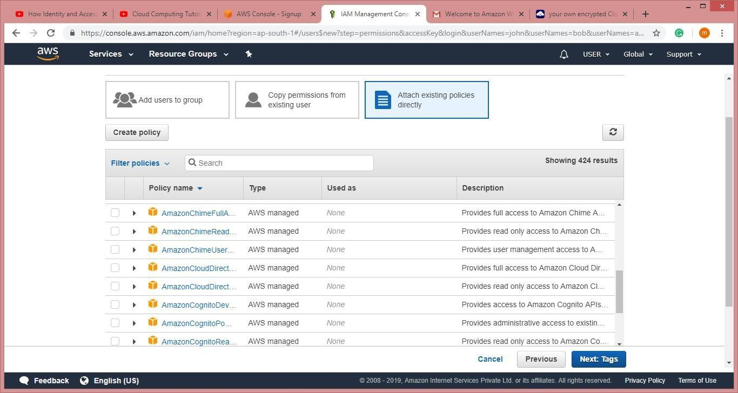

**Step14:** Click On Create User (Here Users are created.)

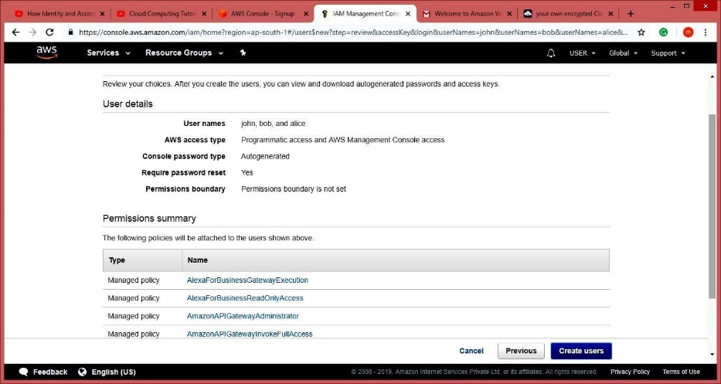

**Step15:** Now download the .csv file . and click on close.



**Step16:** Now Goto Account and select My Security Credential tab > Click on Continue to security credentials .  
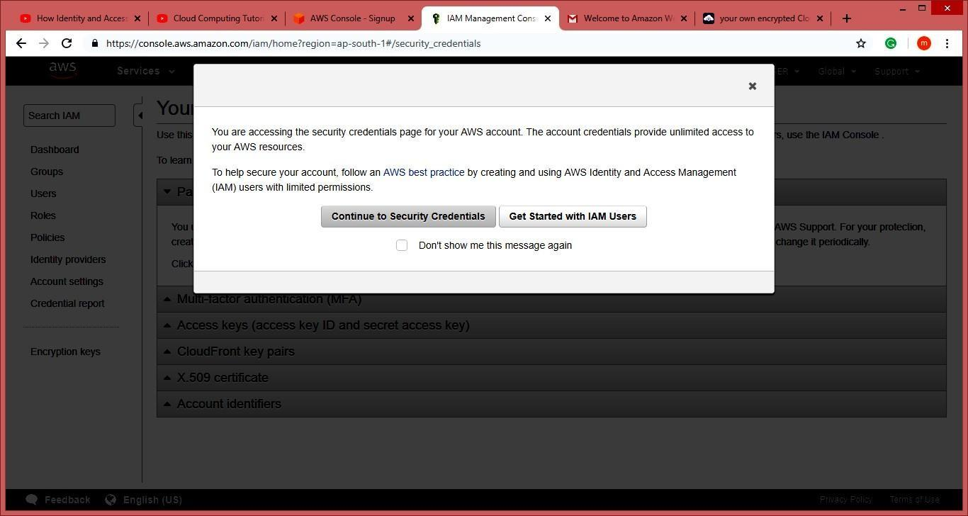

**Step17:** Click on Multi-factor authentication (MFA)

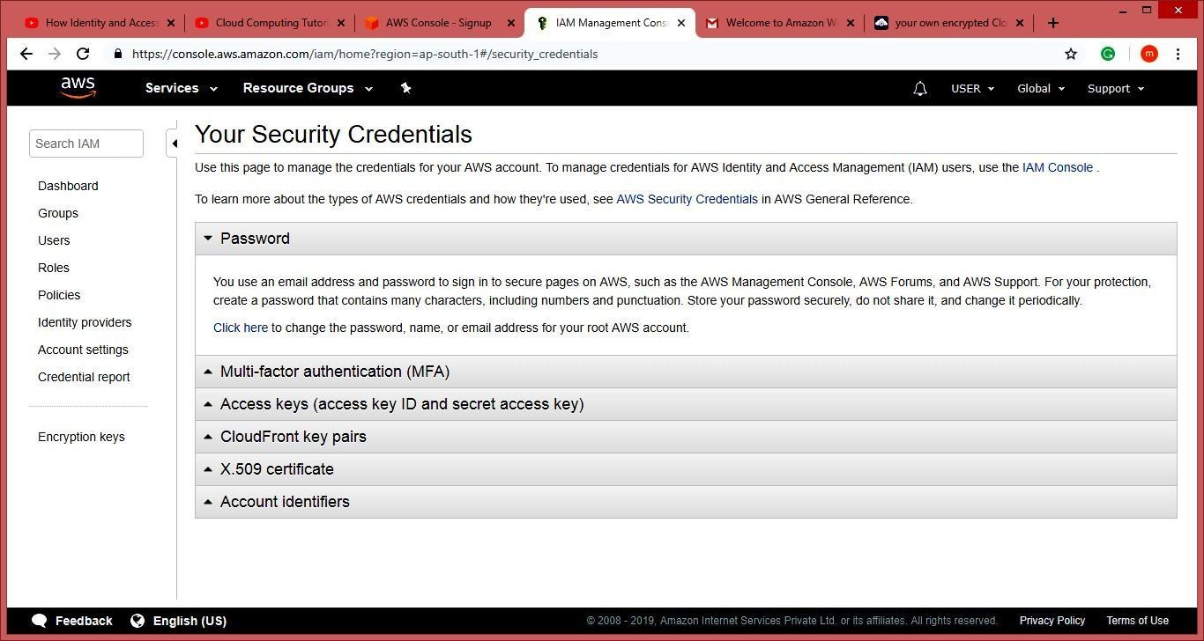

**Step18:** Click On Active MFA

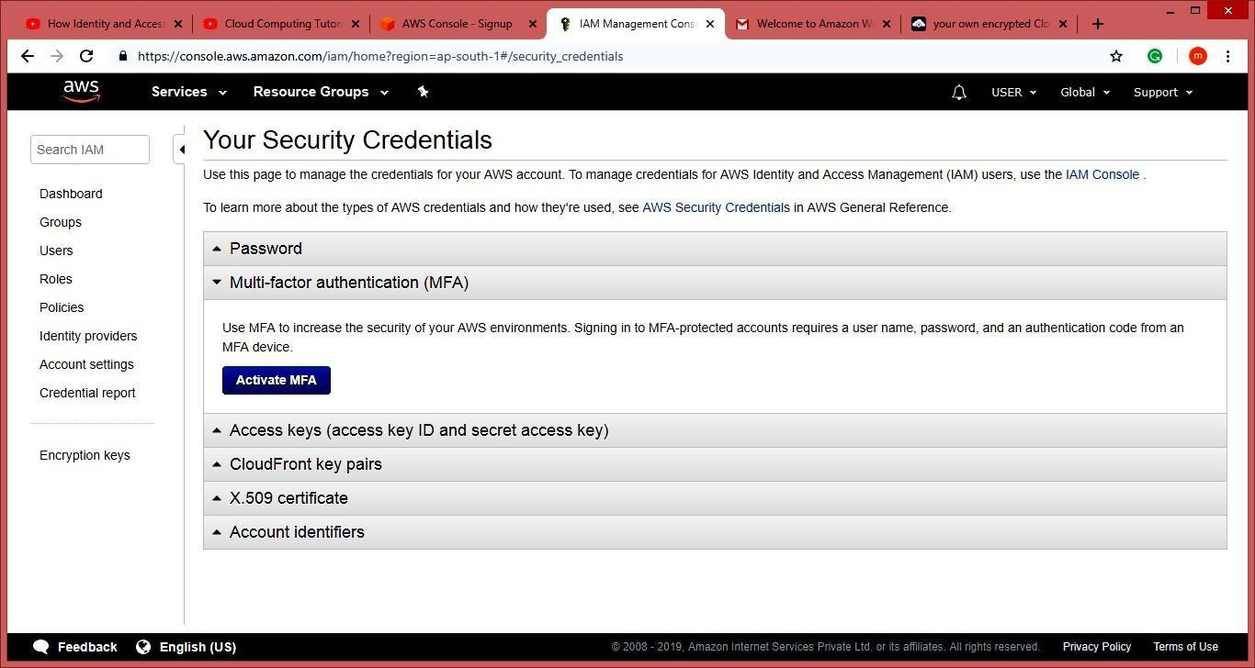

**Step19:** Select Virtual MFA device and Click on Continue tab

**Note:** **Download** **Barcode** **Scanner** **and** **Google** **Authentication** **App** **in** **your** **Mobile** **Phone.**

**Step20:** Scan the QR code and enter the MFA code from ur mobile phone and then click on assign Assign MFA tab

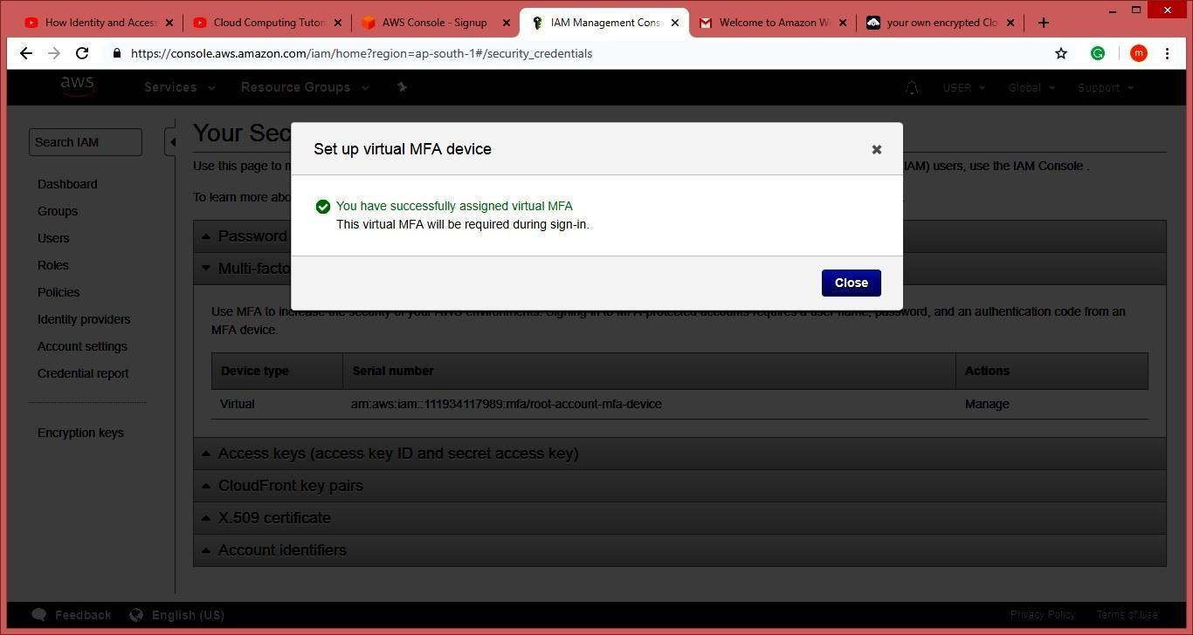

**Step21:** Now the page look like this.

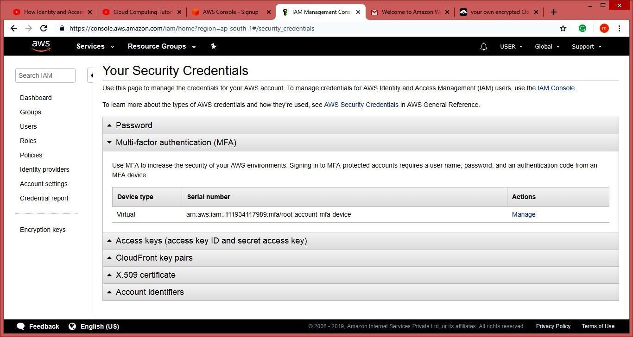

**Step22:** Click On Dashboard Go to Additional Information Select Policy Simulator

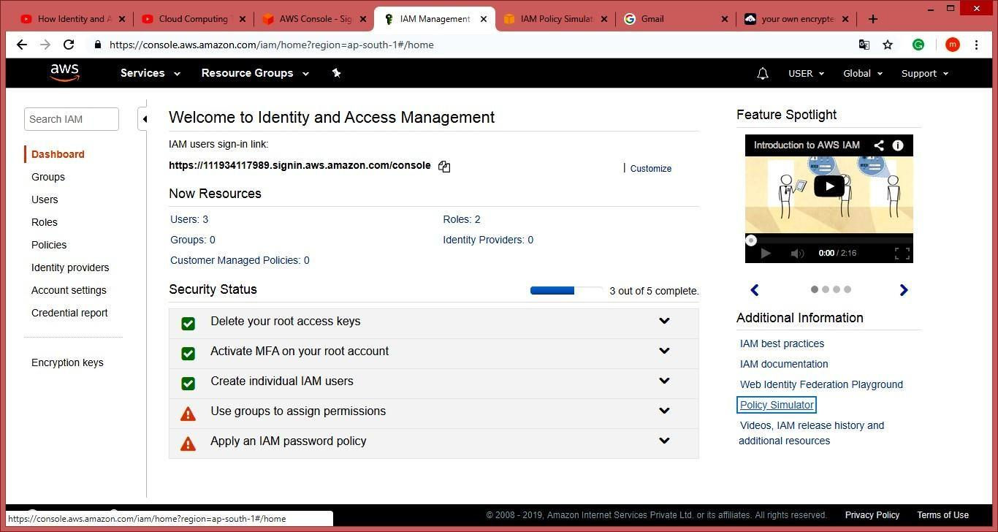

**Step23:** Select The User select services and service action and click on Run Simulator Tab

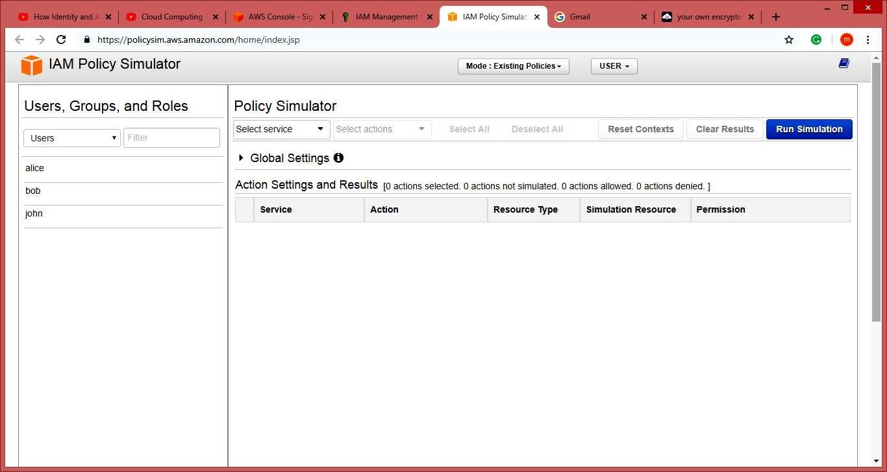

**Practical No. 7**

**Aim: Write a program for web feed**

**Steps:**

**Step1: Open** **Notepad** **File** **Type** **the** **following** **Code** **and** **save** **it** **as** **rss.xml** **extension.**

<?xml version="1.0" encoding="UTF-8"?>

<rss version="2.0">

<channel>

<title>W3Schools Home Page</title>

<link>https:/[/www.w3schools.com](http://www.w3schools.com/)</link>

<description>Free web building tutorials</description>

<item>

<title>RSS Tutorial</title>

<link>https:/[/www.w3schools.com/xml/xml_rss.asp](http://www.w3schools.com/xml/xml_rss.asp)</link>

<description>New RSS tutorial on W3Schools</description>

</item>

<item>

<title>XML Tutorial</title>

<link>https:/[/www.w3schools.com/xml<](http://www.w3schools.com/xml)/link>

<description>New XML tutorial on W3Schools</description>

</item>

</channel>

</rss>

**Step2: Open** **the** **software** **visual** **studio** **2010** **Do** **the** **following** **File** **->** **New** **->** **Website->** **visual** **C#** **->** **ASP.NET** **website** **->** **OK**

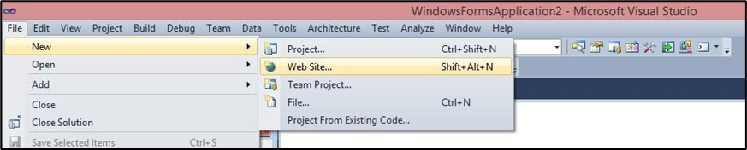

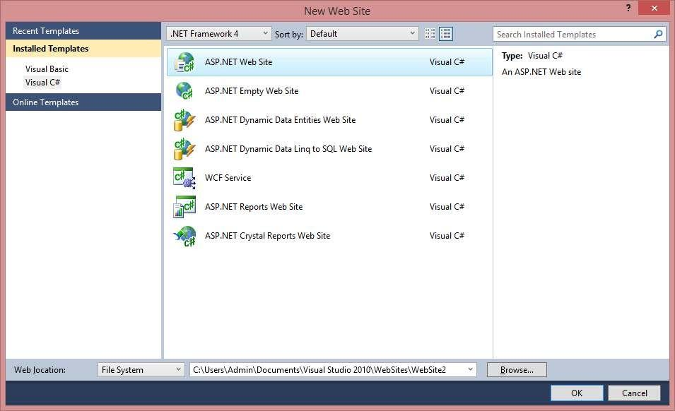

**Step3:** **Now** **copy** **that** **rss** **file** **which** **was** **saved** **with** **.xml** **extention** **inside** **your** **website** **folder.**

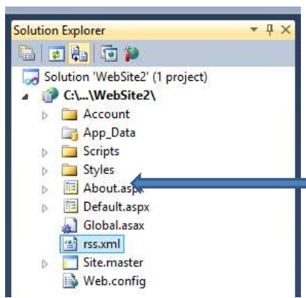

**Step4: Type** **this** **in** **default.aspx** **<p>here** **is** **ur** **<a** **href="rss.xml">feed</a>.</p>**

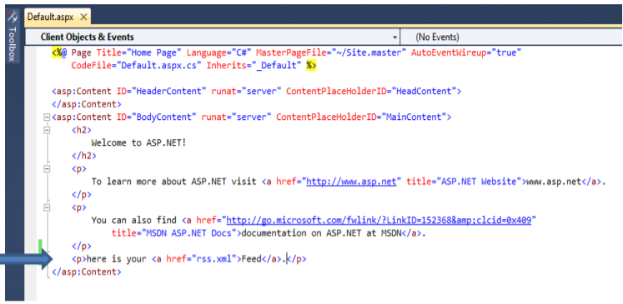

**Step5:** Run the page

**Output:**

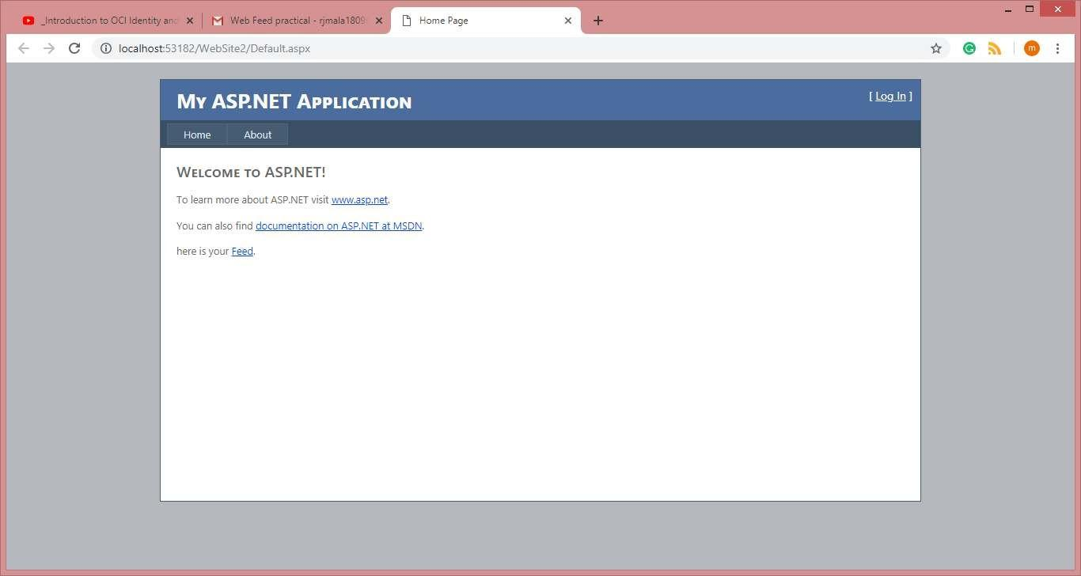

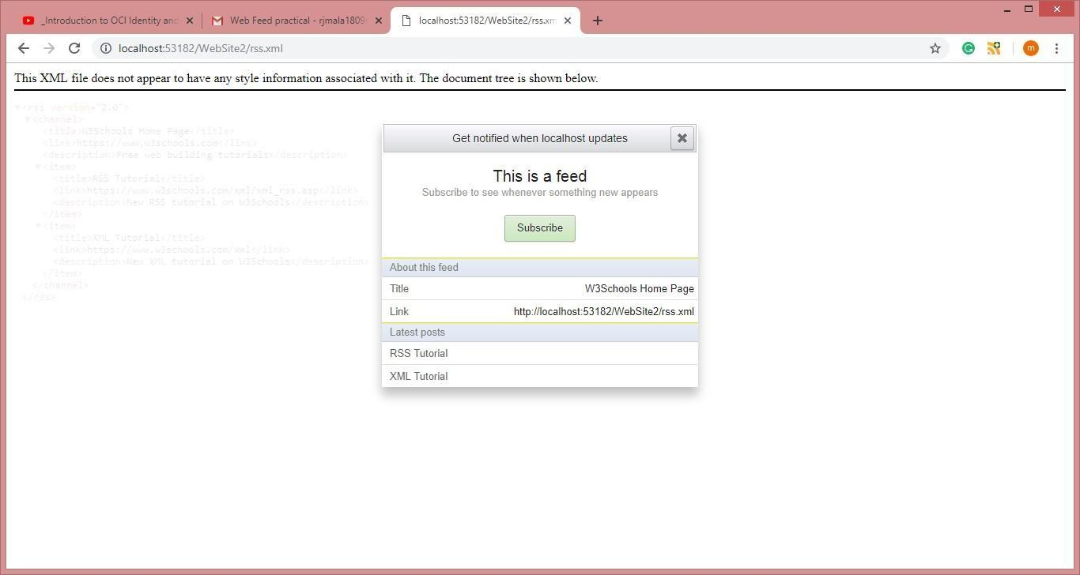

**Practical No. 9**

**Aim:** User Management in Cloud

**Steps:**

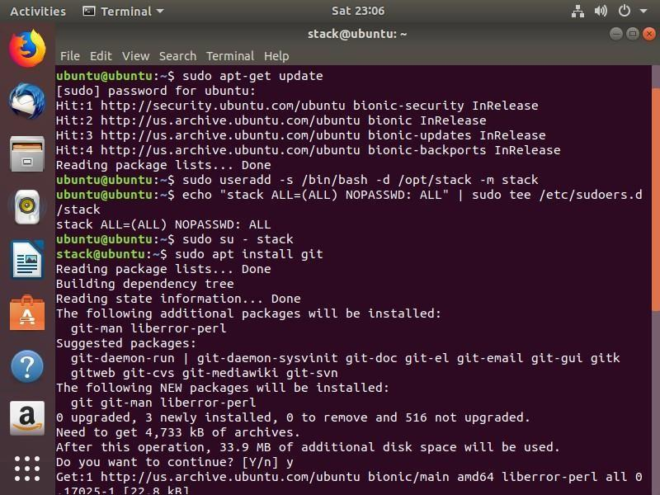

**Step1:** Adding a user on Ubuntu: **sudo adduser rjcs**

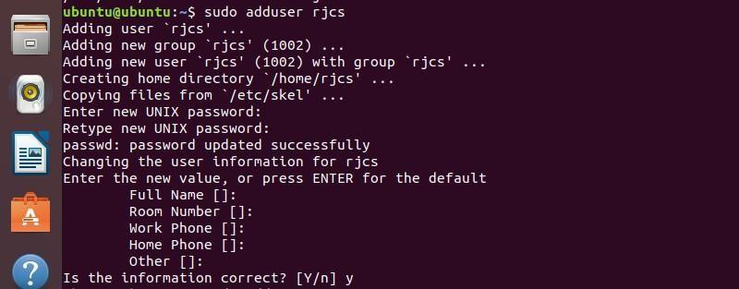

**Step2: To** **add** **a** **system** **user** **rjcs** **run** **the** f**ollowing** **command:**



**Step3: Login as rjcs user by using following command:**





**Step4: Adding** **a** **group** **on** **Ubuntu**

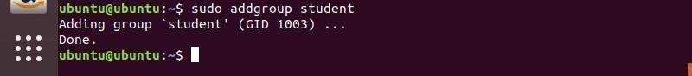

**Step5: Adding** **a** **User** **to** **a** **group** **on** **Ubuntu:**



**You can login as a rjcs and run the following command.**





**Step6:** **Removing** **the** **user** **from** **a** **group** **on** **Ubuntu:**

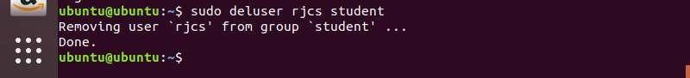

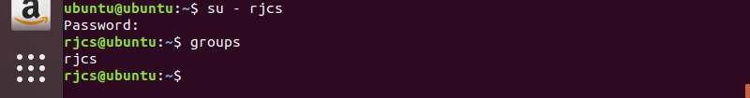

**Step7: Removing a user on Ubuntu:**

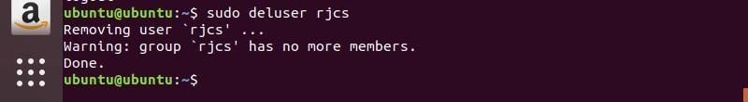

**Step8:** **Deleting** **a** **group** **on** **Ubuntu:**

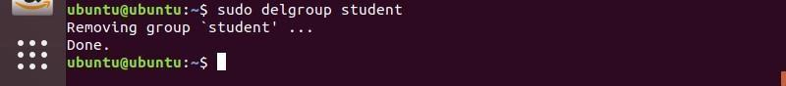

**Step9:** **Listing** **all** **the** **users** **on** **Ubuntu:**

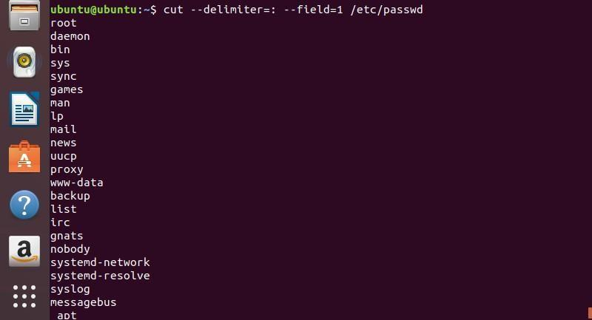

**Step10:** **Listing** **all** **the** **groups** **on** **Ubuntu:**

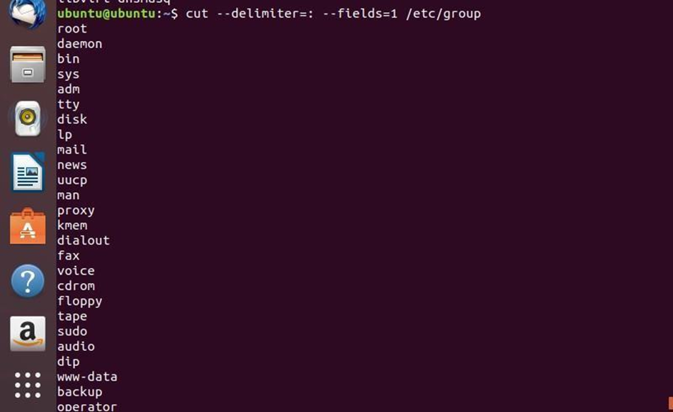

**Step11: Listing** **all** **the** **user** **in** **a** **group** **on** **Ubuntu**



**Practical No. 10**

**Aim:** Study and implementation of Role Based Access Control in AWS Cloud

**Steps:**

**Step1: Open your browser and visit the AWS Free Tier Sign-Up page 👉** [**https://aws.amazon.com/free**](https://aws.amazon.com/free) **> Click on "Create an AWS Account".**

**Step2: Enter Your Details:**

1. Account Information
2. AWS Account Name [MyCloudLearning]
3. Choose Account Type
4. Payment Information
5. Verify Your Identity
6. Choose a Support Plan [Free Basic Plan]

**Step3: Sign in to AWS Management Console, Once logged in, ensure that you are in the correct AWS region (top-right corner).**

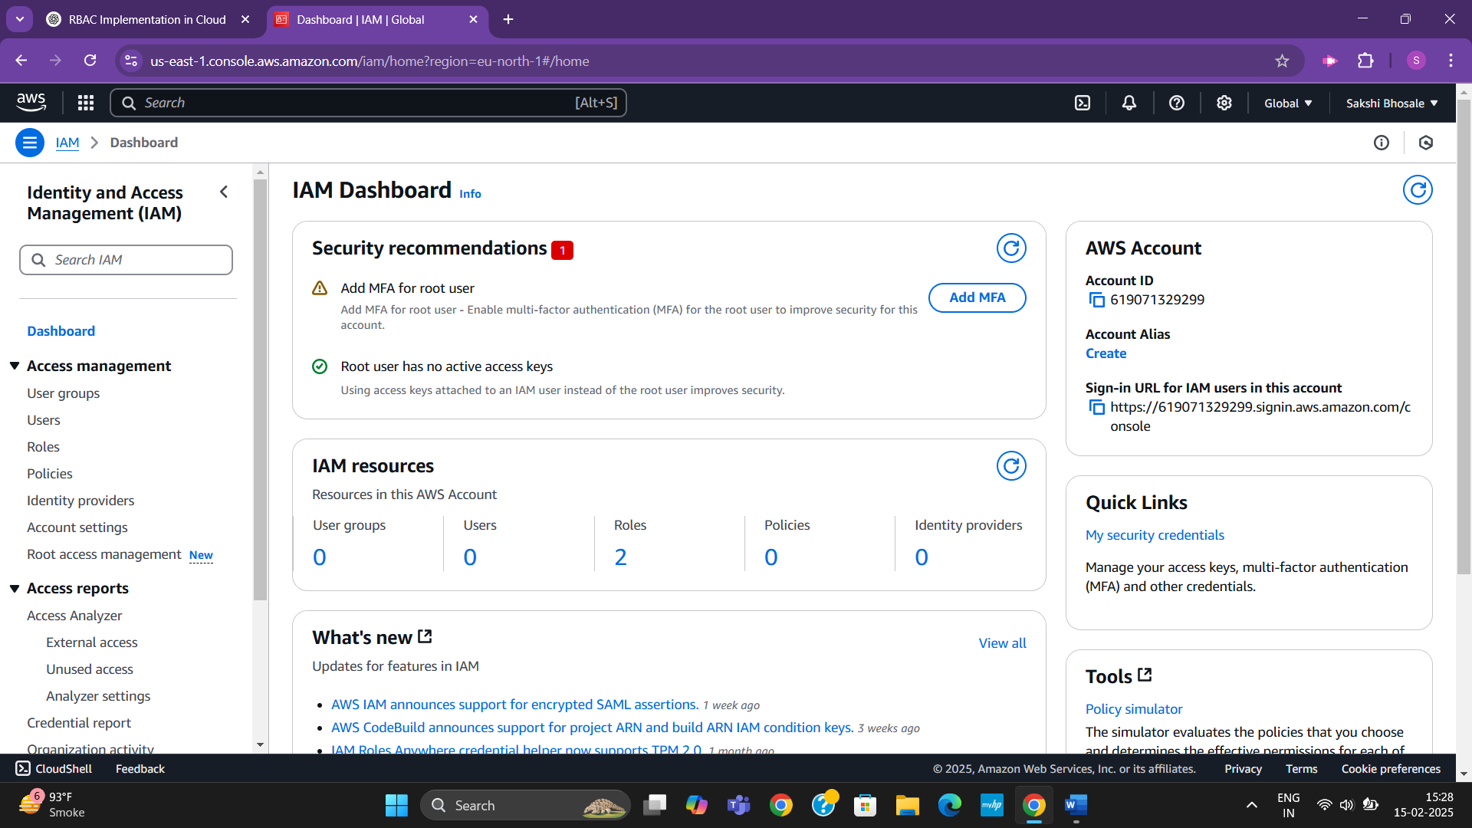

**Step4: Type "IAM" and click on IAM under Services > Roles > Create Role**

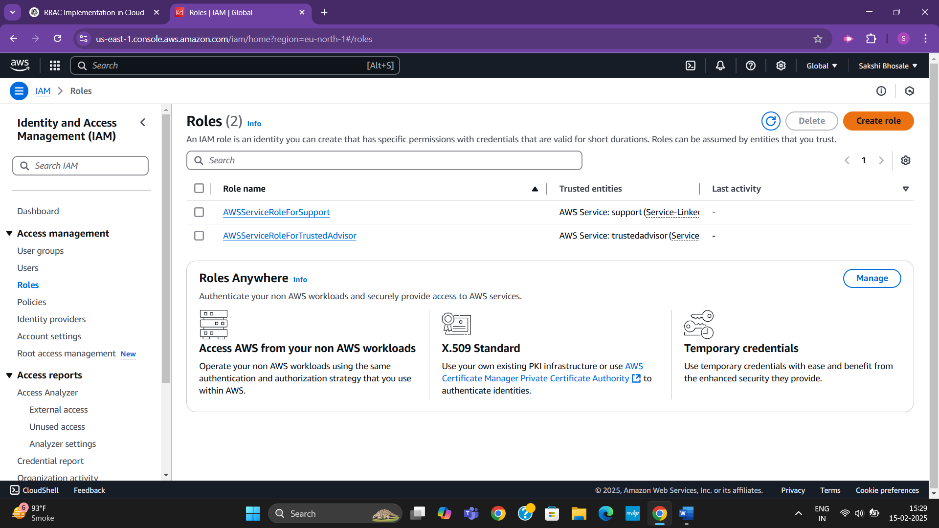

**Step5: Select AWS Service & choose EC2 as the trusted entity > Next [select role type]**

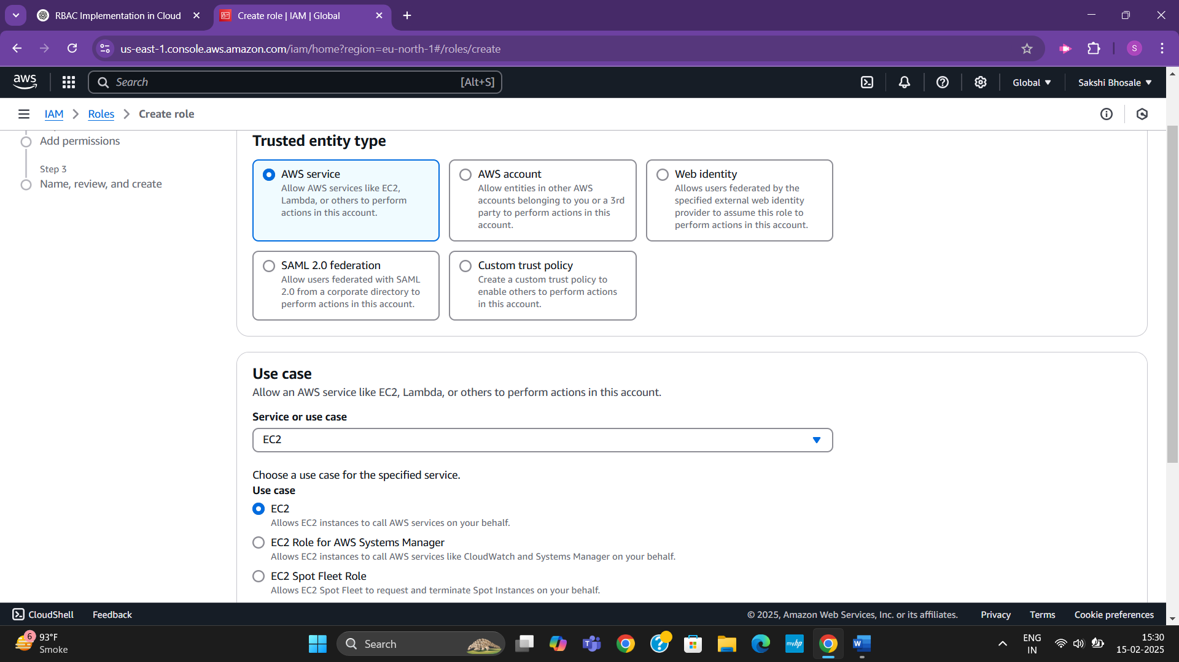**\**

**Step6: Select the AmazonS3ReadOnlyAccess checkbox > Next**

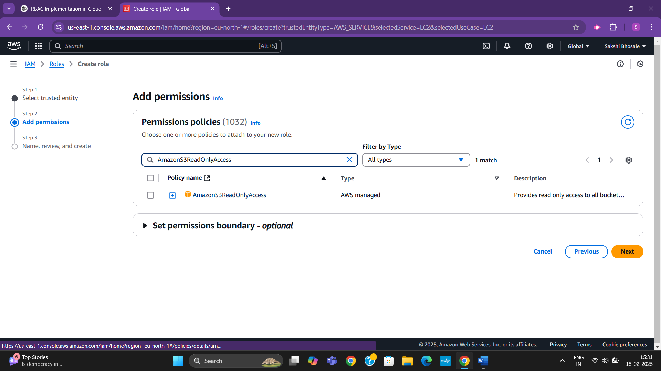

**Step7: Enter a meaningful role name, [S3_ReadOnly_Role] > Create Role at bottom of page**

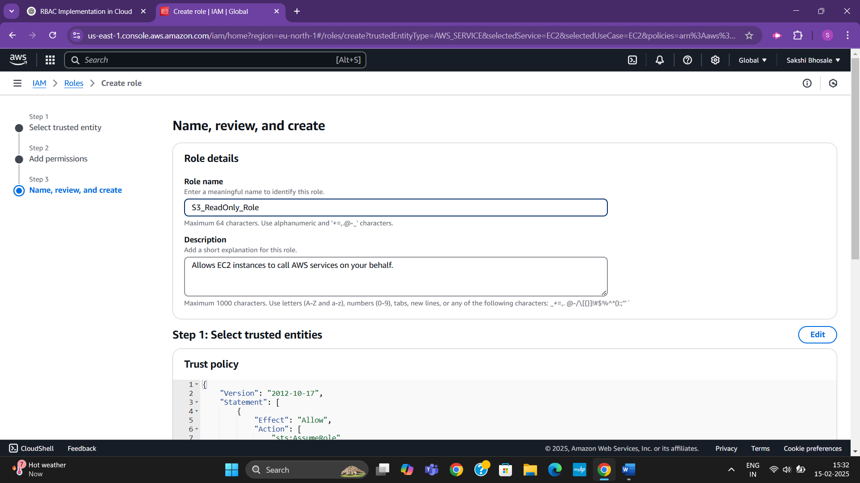

**You have successfully created an IAM role. Now, you can attach this role to an EC2 instance or other AWS services.**

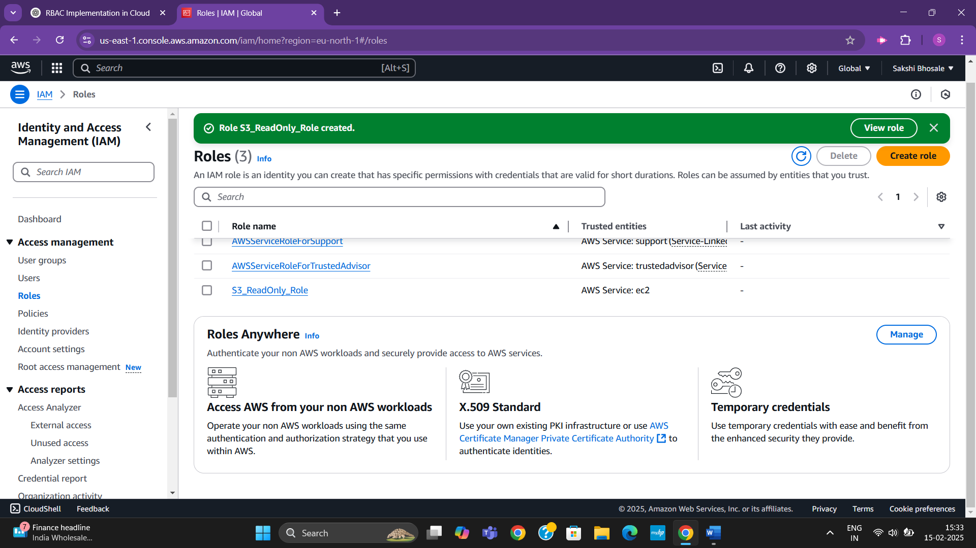

**Step8: In EC2 Dashboard, click on Instances (left side panel) > (blue)Launch Instances. [Launch EC2 Instance]**

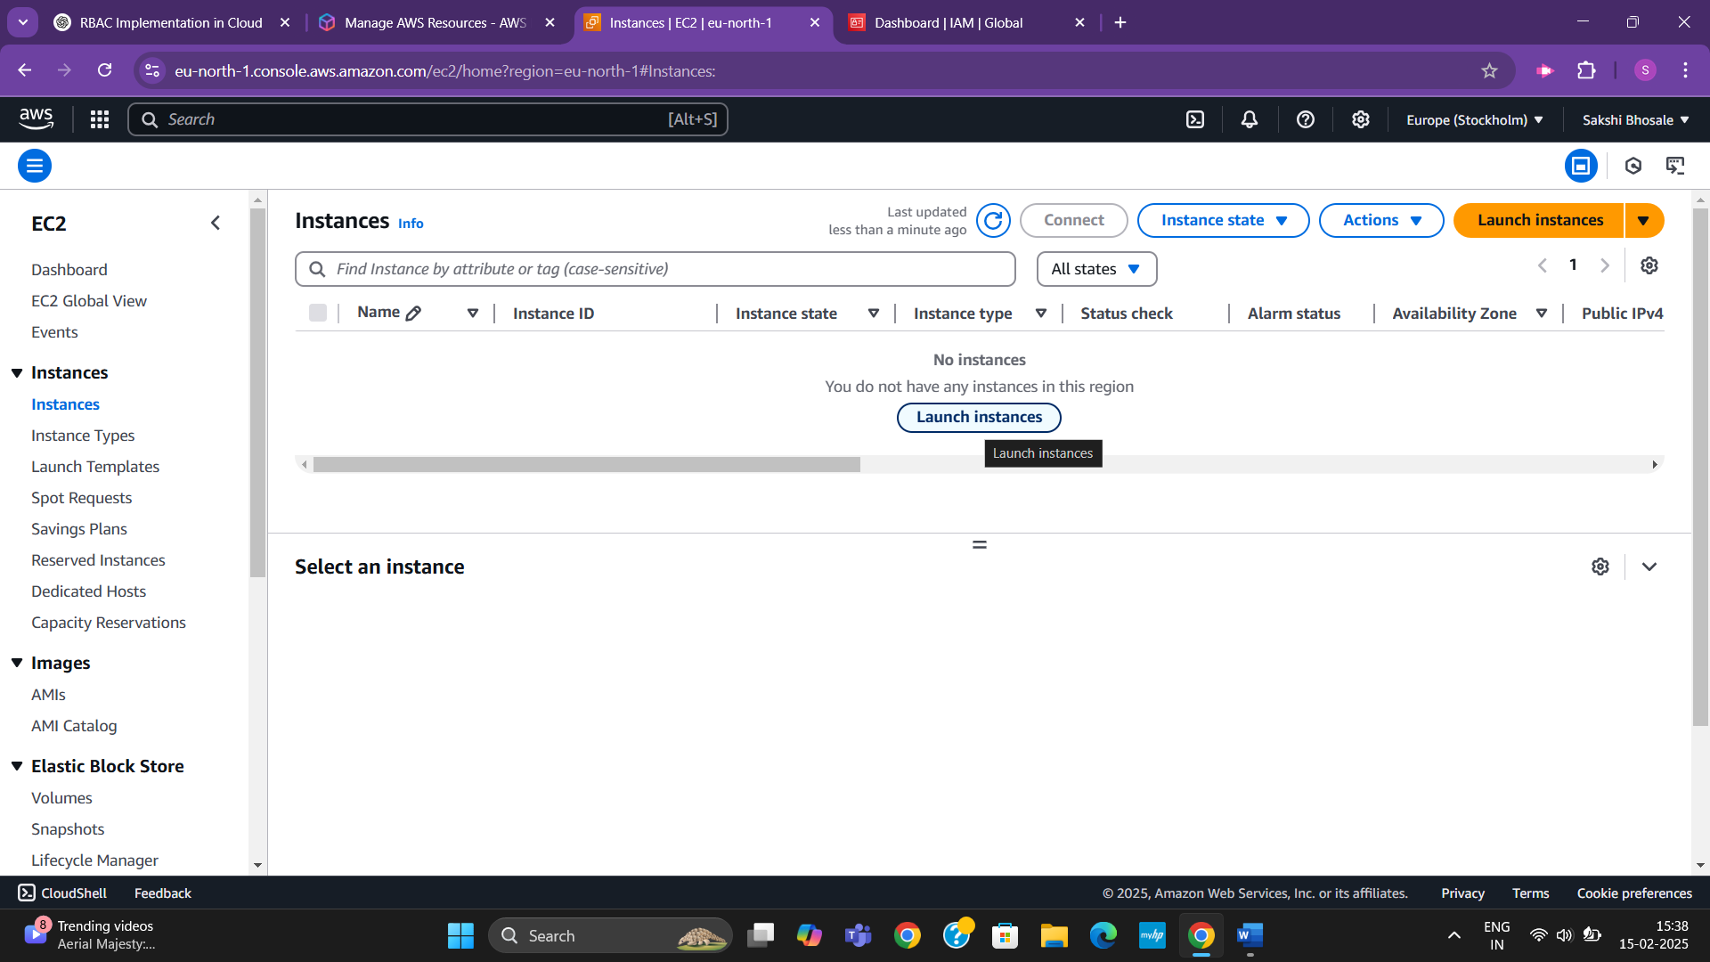

**Step9: Configuring EC2 Instance by selecting below things:**

1. Name Your Instance under Name and Tags [MyTestEC2]
2. Scroll down to Application and OS Images (Amazon Machine Image - AMI) > Choose Amazon Linux 2023 (Free Tier eligible) (will install amazon linux)
3. Under Instance Type, select t2.micro OR t3.micro (Free Tier eligible)
4. Under Key pair (login), click Create new key pair [MyEC2Key] > RSA as (key type) > Create Key Pair and download the .pem file.
5. Under Network Settings, leave the defaults & make sure Allow SSH traffic is enabled so you can connect to the instance.
6. Under Configure Storage, keep the default 8 GiB (General Purpose SSD - gp3).

**Step10:** Now, you will attach the IAM role you created (S3_ReadOnly_Role) to the EC2 instance by scroll down to Advanced Details > IAM Instance Profile (dropdown) > select S3_ReadOnly_Role > Launch Instance

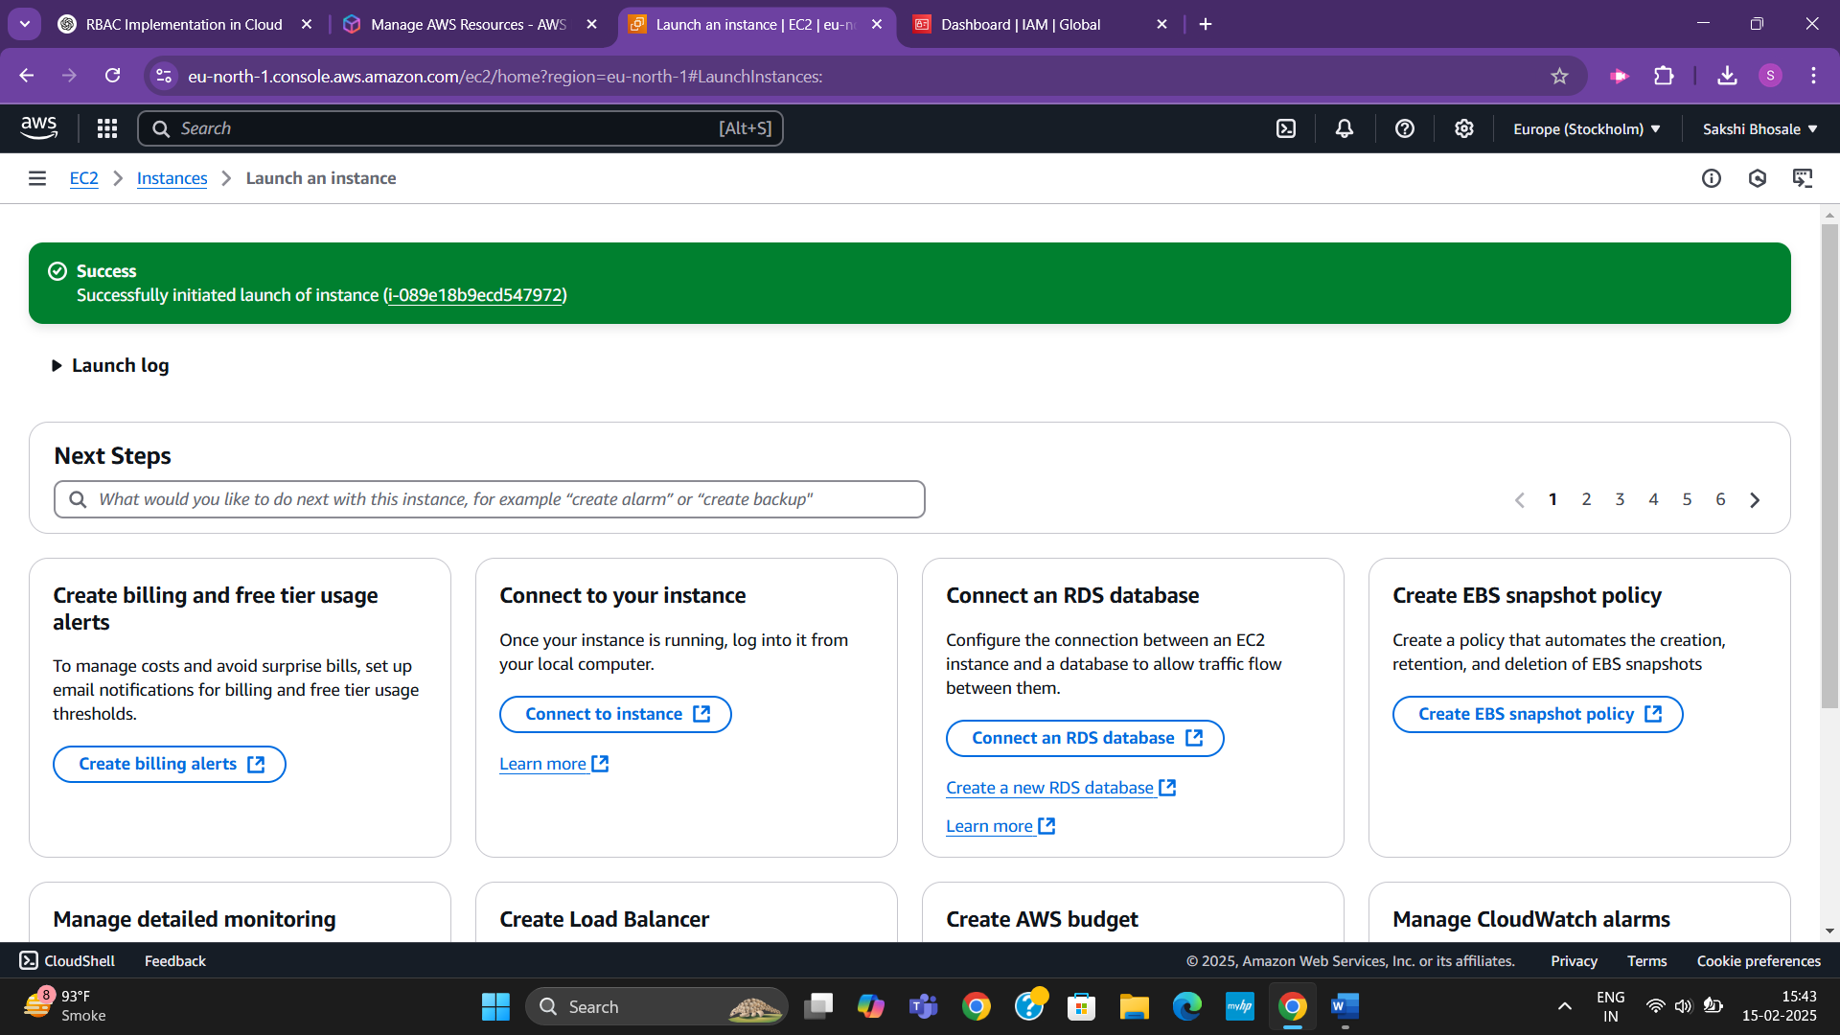

**Once the instance is launched, verify that the IAM role is attached**

**Step11:** EC2 Dashboard → Click Instances (left panel) > find launched instance > click on it & open its details > In Details tab, look ‘IAM Role field’ it should show S3_ReadOnly_Role

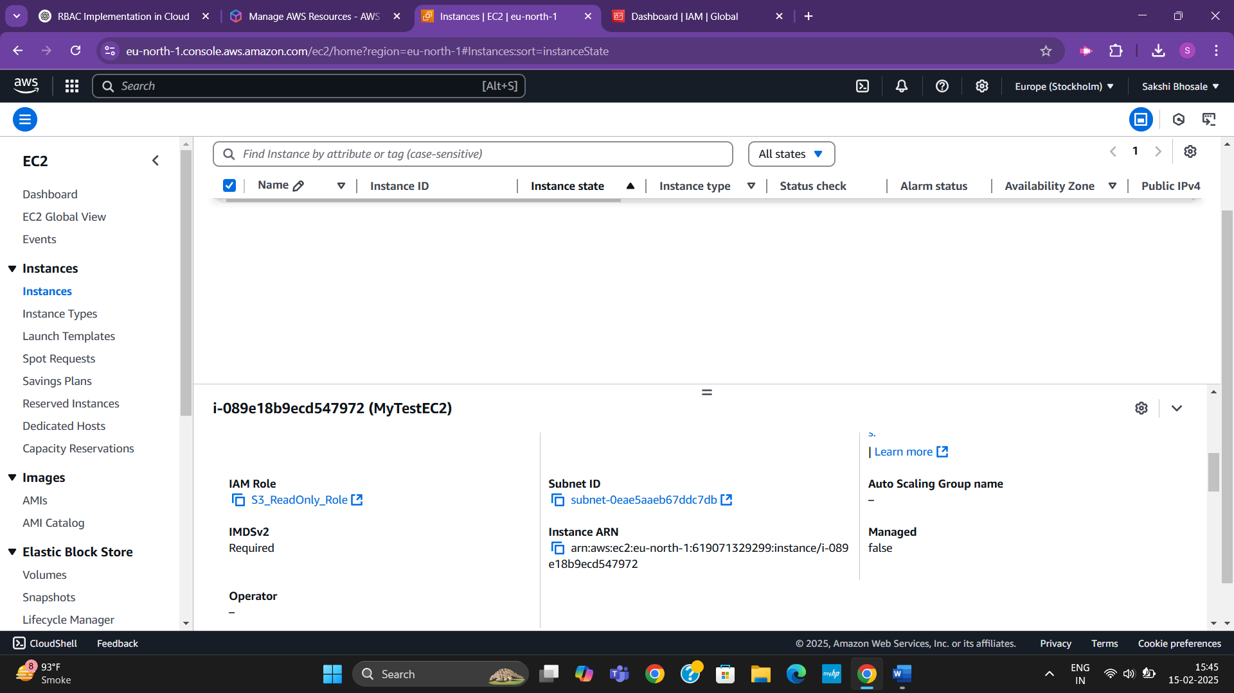

**If the IAM role is displayed correctly, your EC2 instance has IAM permissions attached successfully.**

**Step12: Now, let’s connect the role to the instance and accessing S3:**

1. Under Instance Details, find the Public IPv4 address and copy it
2. Open Command Prompt, run the command “ssh -i your-key.pem ec2-user@your-ec2-public-ip”

Replace ‘your-key.pem’ → Path to your downloaded key file

‘your-ec2-public-ip’ → The public IPv4 address of your EC2 instance > Yes

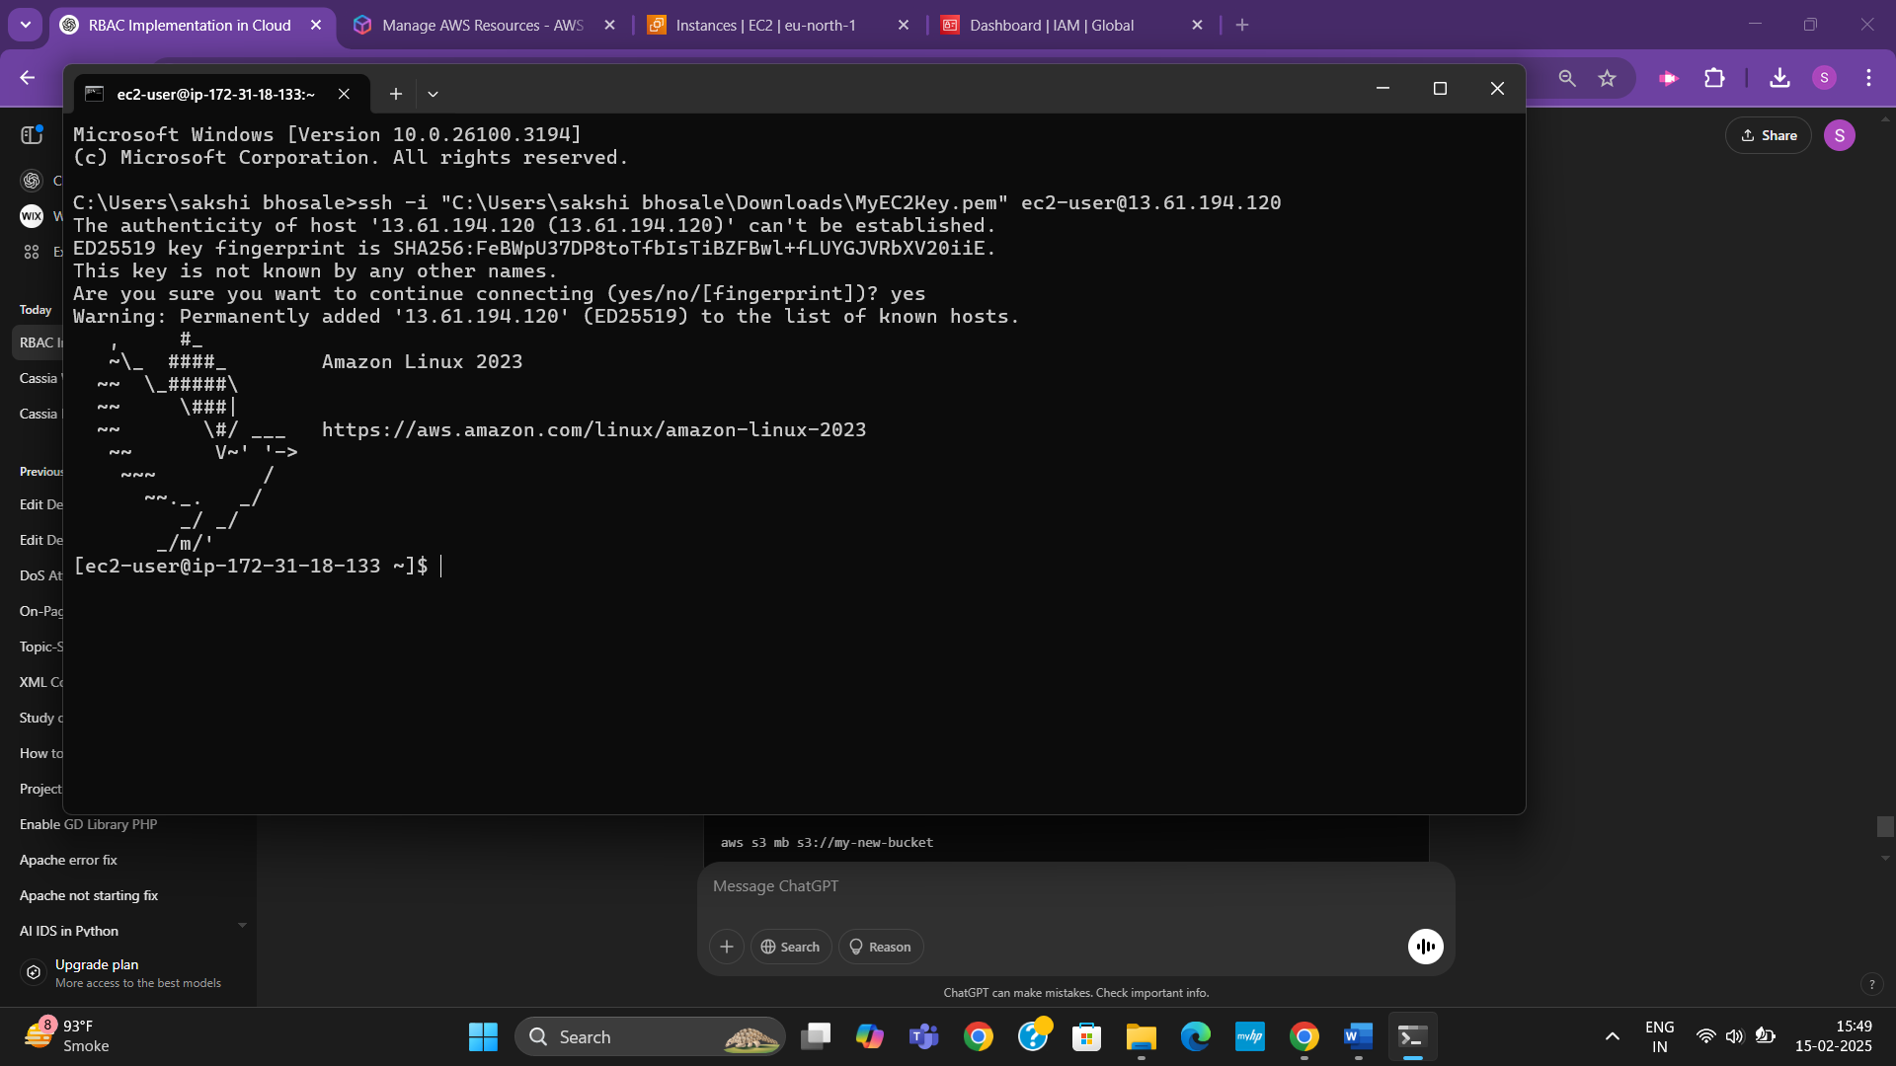

**Step13: Test S3 Read-Only Access as we are connected to instance, follow below steps:**

1. Run this command to list all S3 buckets in your AWS account [aws s3 ls] - It will successfully read the command

**Step14:** Test S3 Modify Access by creating a new S3 bucket type this command [aws s3 mb s3://my-new-bucket]

You should get a permission denied error, confirming that the role only allows read access

